A

Report on

## WEATHETER REPORTING SYSTEM

PYTHON PROGRAMMING PROJECT

Submitted in partial fulfilment of the requirements for The Award of the degree of

## BACHELOR OF TECHNOLOGY

In

Department of Electronics and communication of Engineering

## G.Lovely Kumari 22K81A04L4

Under the esteemed guidance of

R.Sree Lakshmi

## ASSISTANT PROFESSOR DEPARTMENT OF CSE



DEPARTMENT OF COMPUTER SCIENCE AND ENGINEERING

St. MARTIN’S ENGINEERING COLLEGE

UGC AUTONOMOUS

NBA & NAAC A+ Accredited Dhulapally, Secunderabad – 500100

St. MARTIN’S ENGINEERING COLLEGE

UGC AUTONOMOUS

NBA & NAAC A+ Accredited

Dhulapally, Secunderabad – 500100

# College Code: K8

CERTIFICATE

# This is certify that the PYTHON PROGRAMMING PROJECT entitled “WEATHER REPORTING SYSTEM” is a bonafide record of independent work done by G.LOVELY KUM(22K81A04L4) under my

supervision and guidance, submitted to St. MARTIN’S ENGINEERING COLLEGE, Hyderabad, in partial fulfilment for

# the award of the Degree of Bachelor of Technology in Computer

Science and Engineering.

# Project Internal Guide

R.SreeLakshmi (Dept. of CSE)

# ……………………………..

Head of Department

# Dr. R.Ranadheer Reddy (Dept. of S and H)

…………………………………

# Principal

(Dr. ) P.SANTOSHKUMARPATRA

# ……………………………………………..

## CONTENTS

ABSTRACT i

## CHAPTER 1- INTRODUCTION 1

## CHAPTER 2-LITERATURE SURVEY 3

## CHAPTER 3-SYSTEM ANALYSIS 6

## EXISTING SYSTEM 6

## PROPOSED SYSTEM 6

## CHAPTER 4- SYSTEM REQUIREMENT 7

## CHAPTER 5- ALGORITHM 8

## CHAPTER 6- SYSTEM ARCHITECTURE 9

## CHAPTER 7- SYSTEM IMPLEMENTATION 10

## CHAPTER 8- SYSTEM TESTING 16

## CHAPTER 9- OUTPUT SCREENS 18

## CHAPTER 10- CONCLUSION 22

## CHAPTER 11- FUTURE ENHANCEMENT 23

## CHAPTER 12- REFERENCES 24

Abstract

The Weather Forecast Project Python is a console-based application written in the Python programming language. The project is open source, and it was made for novices who wish to learn Python. This Weather Forecast Python With Source Code can run in console mode, which means that you have to enter it manually.

People can make smart choices about when and where to go on vacation – People’s work schedules are so full that they rarely have time to rest or even spend time with each other. Most of the time, workaholics like this use their vacation time to go on a relaxing trip

The weather forecast helps keep people safe – When it rains a lot, rivers and other bodies of water flood, sending water into people’s homes, gardens, and even public spaces. This affects a lot of people. If flooding comes out of nowhere, it can kill a lot of people.

Weather forecasting is important in the transportation sector – There have been reports of ships turning over and planes crashing in different parts of the world. Most of the time, bad weather is the main cause of these kinds of accidents.

Benefits of Agriculture – In the past, farmers lost a lot of money because of changes in the weather. Now, farmers use new technology to plan their schedules. Farmers can plan what to

plant and when to plant it by looking at weather forecasts.

This Weather Forecast Using Python is important because it predicts weather conditions to

* + 1. INTRODUCTION

i.Weather Forecast Project In Python was developed using Python Programming, this Simple Project With Source Code created using console based, and this project is good for the beginners or the students who wants to learn programming specially python programming language.

A Weather Prediction Project In Python is a simple console based application using machine learning which helps to determine if the current situation of weather is good to play or not. It is done under the supervised learning in . A Weather Prediction Project In Python is a simple console based application using machine learning which helps to determine if the current situation of weather is good to play or not. It is done under the supervised learning in which data are given first to train the system and then the result for new data will be produce

give people and organizations information they can use to reduce losses caused by weather

and improve societal benefits, such as protecting life and property, improving public health

and safety, and helping the economy and quality of life. .

NUMPY:NumPy is the fundamental package for scientific computing in Python. It is a Python library that provides a multidimensional array object, various derived objects (such as masked arrays and matrices), and an assortment of routines for fast operations on arrays, including mathematical, logical, shape manipulation, sorting, selecting, I/O, discrete Fourier transforms, basic linear algebra, basic statistical operations, random simulation and much more.

At the core of the NumPy package, is the ndarray object. This encapsulates n-dimensional arrays of homogeneous data types, with many operations being performed in compiled code for performance. There are several important differences between NumPy arrays and the standard Python sequences:

Pandas: Pandas is a Python library used for working with data sets.

It has functions for analyzing, cleaning, exploring, and manipulating data.

The name "Pandas" has a reference to both "Panel Data", and "Python Data Analysis" and was created by Wes McKinney in 2008.

Pandas allows us to analyze big data and make conclusions based on statistical theories. Pandas can clean messy data sets, and make them readable and relevant.

Relevant data is very important in data science.

Matplotlib: Matplotlib is a low level graph plotting library in python that serves as a visualization utility. Matplotlib was created by John D. Hunter.

Matplotlib is open source and we can use it freely.

Matplotlib is mostly written in python, a few segments are written in C, Objective-C and Javascript for Platform compatibility.

he libraries that have been used are the most famous ones for data analysis, plot and mathematical operations (pandas, matplotlib, numpy). Then there are some of them for advanced data visualization (like folium) and some of them are specific libraries for ARIMA models (like statsmodels). Here is the code for the import:d.

* + 1. LITERATURESURVEY

Python is a high-level, interpreted programming language that is widely used in various domains such as web development, data science, machine learning, and artificial intelligence. Python's popularity is due to its simplicity, readability, and versatility. Python has a vast standard library and a large community of developers who contribute to the development of libraries and frameworks that extend its capabilities. Python is easy to learn and code, which makes it a popular choice for beginners. Its syntax is clear and concise, making it easy to read and understand. Python's dynamic nature allows for rapid development and testing, which is why it is a popular choice for prototyping and building applications. Python is also cross-platform, which means that it can run on various operating systems such as Windows, macOS, and Linux. Python's applications are diverse and its popularity is expected to continue to grow in the future due to its versatility and the large community of developers supporting its development.

* 1. APPLICATIONS:

In game development, Python is used for creating games using libraries such as Pygame and PyOpenGL.

In desktop applications, Python is used for creating cross-platform applications using libraries such as PyQt and wxPython.

In automation of repetitive tasks, Python is used for scripting and automation using libraries such as Selenium and PyAutoGUI.

* 1. VERSIONS OF PYTHON:

There are currently two major versions of Python in use: Python 2 and Python 3.

Python 2 was the first version of Python that was widely used, and it is still used today in some legacy systems. However, it is no longer being actively developed and will no longer receive updates or security patches after January 1, 2020.

Python 3 is the current version of Python and is the version that is recommended for new projects. Python 3 is not backward-compatible with Python 2, which means that code written in Python 2 may need to be updated to work with Python 3.

Python 3 has several advantages over Python 2, including improved Unicode support, better syntax and error handling, and improved performance. The latest version of Python 3 is Python 3.9.6, which was released on June 28, 2021.

Here are the major versions of Python and their significant developments:

* Python 1.0 (1994): The first stable release of Python.
* Python 2.0 (2000): Introduced list comprehensions, a garbage collector, and support for Unicode.
* Python 2.2 (2001): Introduced the "with" statement for file handling and support for iterators.
* Python 2.3 (2003): Introduced the "enumerate" function, the "set" data type, and support for generators.
* Python 2.4 (2004): Introduced the "decimal" module and support for function decorators.
* Python 2.5 (2006): Introduced the "with" statement for use with arbitrary context managers and support for conditional expressions.
* Python 2.6 (2008): Introduced the "collections" module and support for "itertools" module.
* Python 2.7 (2010): Introduced the "print" function and support for dictionary comprehensions.
* Python 3.0 (2008): A major release that introduced significant changes to the language, including improved Unicode support, a new I/O library, and changes to the print statement.
* Python 3.1 (2009): Introduced support for the "bytearray" data type and a new "memoryview" object.
* Python 3.2 (2011): Introduced the "os.scandir()" function and support for the "pickle" protocol 3.
* Python 3.3 (2012): Introduced the "yield from" statement and support for the "u'unicode'" syntax.
* Python 3.4 (2014): Introduced the "asyncio" module and support for the "enum" module.
* Python 3.5 (2015): Introduced support for the "async" and "await" keywords and the "typing" module.
* Python 3.6 (2016): Introduced support for formatted string literals and the "f-strings" syntax.
* Python 3.7 (2018): Introduced support for the "asyncio.run()" function and the "dataclasses" module.
* Python 3.8 (2019): Introduced support for the "walrus" operator and the "typing.TypedDict" class.
* Python 3.9 (2020): Introduced support for dictionary union operators and the "zoneinfo" module.

## SYSTEM ANALYSIS

3.

* 1. EXISTING SYSTEM AND DISADVANTAGES Weather forecasting is the application of science and technology to predict

the state of the atmosphere for a given location. Weather forecasts are made by collecting quantitative data about the current state of the atmosphere and using scientific understanding of atmospheric processes to project how the atmosphere will evolve. There are a variety of end users to weather forecasts.

# Weather warnings are important forecasts because they are used to protect life

and property.

# In ancient times, forecasting was mostly based on weather pattern observation. Over the years, the study of weather patterns has resulted in various techniques for rainfall forecasting. Present rainfall forecasting embodies

a combination of computer models, interpretation, and an acquaintance of weather patterns. So, we created a web application to predict the weather in accuracy format to help user can get the weather detail.

* 1. **PROPOSED SYSTEM AND ADVANTAGES**

Weather report application is a web based application through which you

will able to get all the reports related to weather forecasting of any locations. Its geographical locator which will be received through your browser setting and server configuration will automatically identify the location and able to present its weather details such as Temperature, Direction of Wind, Humidity etc.

To develop software for forecasting the weather involving Wind Speed, Cloud Cover, Rain or Snow in order to nurture the needs of any person aroun

## SYSTEMREQUIREMENT

* 1. SOFTWARE REQUIREMENTS:

Operating system:windows IDE:python 3.11 GUI:Tkinter

* 1. HARDWARE REQUIREMENTS:

Processor:Intel i3 Hard disk:500 gb Ram:4gb

## ALGORITHM

STEP 1:START

STEP 2:Import tkinter and web browser

STEP 3:set the geometry

STEP 4: STEP 4:

Create a labels to display the introduction and 1st section define my_link function: To exhibit the URL

Create the labels to display the questions define button function:

STEP 5:And create Radiobutton to choose the options

STEP Create a button to check

6S:TEP 7:define button1 function:

And Create the Radiobutton to choose option Create a button to check

STEP 8:define button2 function:

And create the radiobutton to choose option Create a button to check

STEP 9C: reate a label for 2nd section Create a button to check

STEP 10de: fine enter function:

To enter the answer in text boxes Create a button to check the answers

STEP 11E: ND

## SYSTEM ARCHITECTURE

5.1 FLOW CHART AND IT’S DESCRIPTION

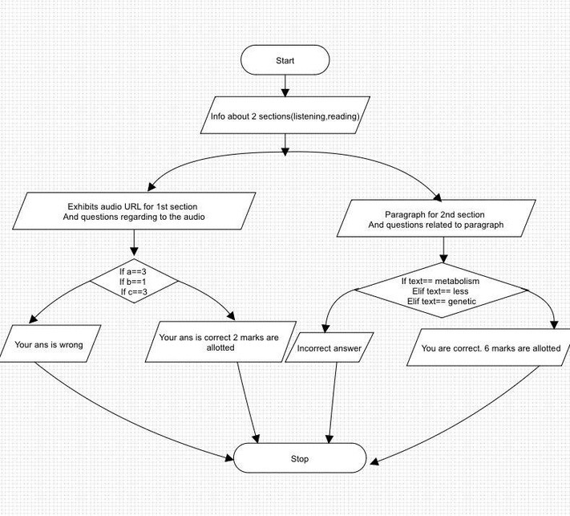

This program gives the information about two sections they are listening and reading. It starts the 1st section i.e., listening it displays URL and you have to answer the questions regarding to that recorded audio (URL) , it will allot you 2 marks if answer is correct. Then you have to start your 2nd section which is reading, that provides a small paragraph and questions. You have to answer those questions and if answer is correct you are allotted with 2 marks.

## SYSTEM IMPLEMENTATION

* 1. CODE:

im

my_link=Tk.Label(root,text='https://takeielts.britishcouncil.org/take-ielts/prepare/free-ielts- practice-tests/listening/section-1', fg='slateblue2', cursor='hand2',font=('Times',10,'underline'))

my_link.pack(padx=1, pady=1, )

my_link.bind('<Button-1>',lambda x:webbrowser.open_new("https://takeielts.britishcouncil.org/take-ielts/prepare/free-ielts- practice-tests/listening/section-1"))

def button():

if a.get()==3:

answer_label=Tk.Label(root,text='Your answer is correct, 2 Marks

are

Allotted',font=('Callibri',8),fg='dark green') answer_label.pack()

else:

answer_label=Tk.Label(root,text='Your answer is wrong',font=("callibri",8),fg='red') answer_label.pack()

a=Tk.IntVar()

label=Tk.Label(root,text='Q1.Nearest station is ? ', font=('Garamond',10)) label.pack() option1=Tk.Radiobutton(root,text='California',variable=a,value=1) option1.pack() option3=Tk.Radiobutton(root,text='Halendale',variable=a,value=3,) option3.pack()

check_button=Tk.Button(root,text='check',bg='thistle',cursor='hand2',command=button) check_button.pack()

def button2():

if b.get()==1:

label=Tk.Label(root,text='your answer alloted',font=('Callibri',8),fg='dark green')

is correct, 2 marks

are

label.pack(padx=5,pady=5,) else:

label=Tk.Label(root,text='your answer is wrong',font=('ccallibri',8),fg='red') label.pack()

b=Tk.IntVar()

label=Tk.Label(root,text='Q2.Number 706 bus goes to ? ',font=('Garamond',10)) label.pack()

option1=Tk.Radiobutton(root,text='central Street',variable=b,value=1) option1.pack()

option2=Tk.Radiobutton(root,text='Shopping center',variable=b,value=2) option2.pack()

check_button=Tk.Button(root,text='check',fg='black',bg='thistle',cursor='hand2',command=butto n2)

check_button.pack()

def button3(): if c.get()==2:

label=Tk.Label(root,text='your answer is correct, 2 marks

allotted',

font=('Callibri',8),fg='dark green') label.pack()

else:

label=Tk.Label(root,text='Your answer is wrong',font=('Callibri',8),fg='red')

label.pack()

c=Tk.IntVar()

label=Tk.Label(root,text='Q3.Number bus goes to station.',font=('Garamond',10)) label.pack()

option1=Tk.Radiobutton(root,text="821",variable=c,value=1) option1.pack() option2=Tk.Radiobutton(root,text='792',variable=c,value=2) option2.pack()

check_button=Tk.Button(root,text='check',bg='thistle',cursor='hand2',command=button3) check_button.pack()

label=Tk.Label(root,text="Congrajulations you are done with 1st section.Now Lets get in to the 2nd Section(READING)*Read the following paragraph and answer the given question*")

label.pack()

label=Tk.Label(root,text="PEOPLE WITH A WEIGHT PROBLEM OFTEN TRY TO DENY

RESPONSIBILITY",fg='rosy brown',font=('Times new roman',8)) label.pack()

label=Tk.Label(root,text=' They do this by seeking to blame their (1) for the fact that

they are overweight and eroneously believe that\n they use (2) energy than thin

people to stay alive. However, recent research has shown that a (3) \nproblem can

be responsible for obesity as some people seem programmed to consume more than others.

The

new\n research points to a shift from trying to change people’s behaviour to seeking an answer the problem in the laboratory.\n{LIST OF WORDS= genetic, More, less, mental, metabolism}')

label.pack ()

var=Tk.StringVar() entry=Tk.Entry(root,textvariable=var) entry.pack()

var=Tk.StringVar() entry=Tk.Entry(root,textvariable=var) entry.pack()

var=Tk.StringVar() entry=Tk.Entry(root,textvariable=var) entry.pack()

def enter():

text=var.get()

if text=='metabolism':

label=Tk.Label(root,text='you are correct.2marks are allotted') label.pack()

elif text=='less':

label=Tk.Label(root,text='you are correct.2marks are allotted') label.pack

elif text=='genetic':

label=Tk.Label(root,text="Your are correct. 6 marks are allotted",fg='dark green') label.pack()

else:

label=Tk.Label(root,text='incorrect answer',fg='red')

label.pack() button=Tk.Button(root,text='check',command=enter,bg='thistl e') button.pack()

root.mainloop()

* 1. MODULUES USED:

Tkinter Tk Geometry

## SYSTEM TESTING

* 1. Test case 1–select the answer for Q.1 given below

Inputs: califorinia

Expected Output:

Your answer is wrong.

* 1. Test case 2s–elect the answer for Q.1

InputsH: alendale

Expected Output:

Your answer is corret.2marks are allotted.

* 1. Tessetlceactsaen3an–swer for Q.2. InputsC:entral Street Expected Output:

Your answer is correct. 2marks are allotted

* 1. Test case 4Se-lect answer for Q2.

InputS: hopping center

Expected output:

Your answer is wrong

* 1. Test case -5Select answer for Q3.

Input- 821 Expected output-

Your answer is wrong

* 1. Test case 6Se- lect answer for Q3.

Input- 792 Expected output-

Your answer is correct. 2marks are allotted

* 1. Test– Enter your 3 answers in entry box

case

Metabo7lism.

Input-Less

Genetic

Expected Output:

You are correct. 6 marks are allotted

* 1. Test – Enter your 3 answers in entry box

case

Metab8olism

InputsM: ore

High

Expected Output:

Incorrect answers

## OUTPUTSCREENS

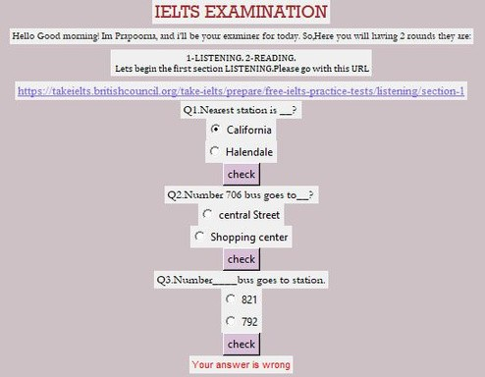

Fig no 8.1:Your answer is wrong.

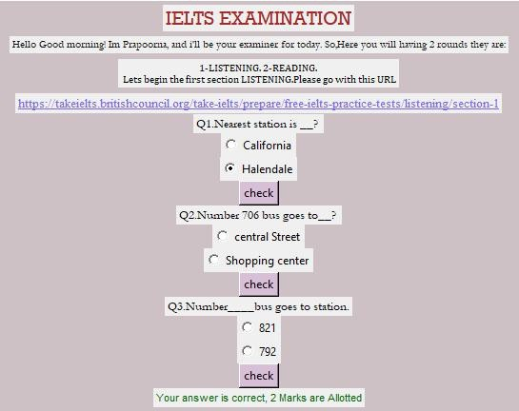

Fig no 8.2y: our answer is correct, 2 marks are allotted

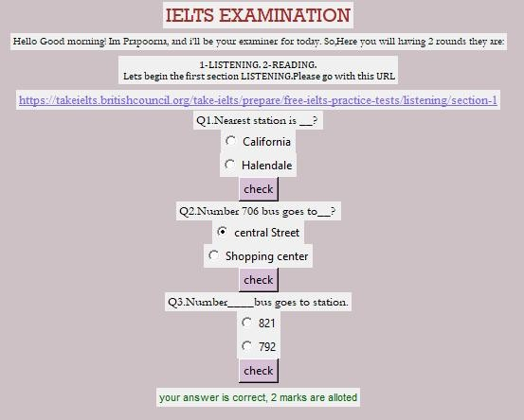

Fig no 8.3y: our answer is correct, 2 marks are allotted

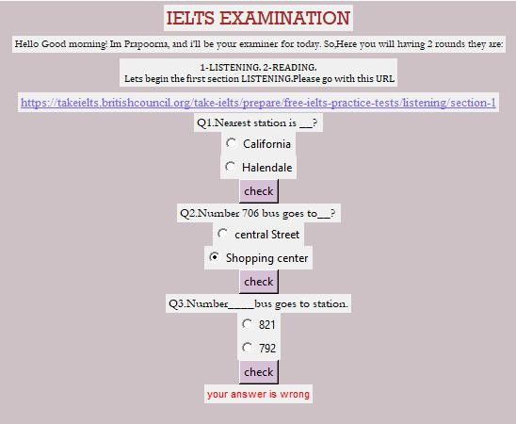

Fig no 8.4:your answer is wrong

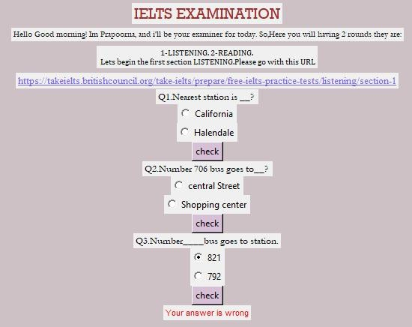

Fig no 8.5:your answer is wrong

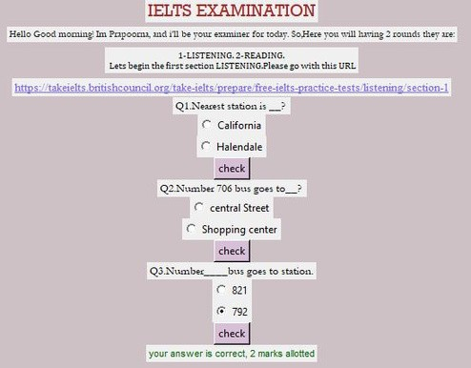

Fig no 8.6:your answer is correct, 2 marks are allotted

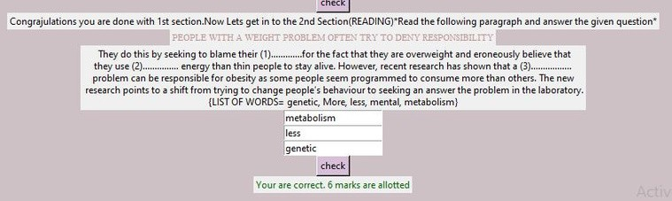

Fig no 8.7:you are correct, 6 marks are allotted

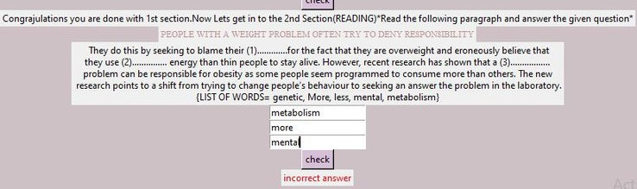

Fig no 8.8:Incorrect answer

1. CONCLUSION

In the era of the global warming, research in weather measurement, monitoring and forecasting are become more and more relevant. This research demonstrates the design and implementation of an affordable mini weather

monitoring system that ensures flexibility, portability, scability and user friendly operations which can provide data of some weather variables including temperature, humidity and pressure. With the advacement of technology weather forecasting has developed to its level best, but there is yet to develop, as far as a nature is so unpredictable. Weather forecasts are increasingly accurate and useful,

and their benefits extend widely across the economy. While much has been accomplished in improving weather forecasts, there remains much room for improvement. Simultaneously, they are developing new technologies and observational netwoeks that can enchance forecaster skill and the value of their services to their users.

.

## FUTURE ENHANCEMENTS

The The website we created in this project can be futher developed into a mobile application so that it can give timely weather updates. These updates will be received in the form of notification in the user’s mobile based on the location they are present in. So the users don’t even have to get into that particular application to know the weather and it saves their valuable time

## td

1. REFERENCES
   * 1. https://[www.ielts.org/](http://www.ielts.org/)
     2. https://[www.cambridgeenglish.org/exams-and-tests/ielts/](http://www.cambridgeenglish.org/exams-and-tests/ielts/)
     3. https://[www.ieltsidpindia.com/](http://www.ieltsidpindia.com/)
     4. https://studyabroad.shiksha.com/exams/ielts
     5. https://[www.ielts.org/about-ielts/what-is-ielts](http://www.ielts.org/about-ielts/what-is-ielts)
     6. https://ieltsonlinetests.com/listening-test-collection
     7. https://ieltsliz.com/ielts-speaking-free-lessons-essential-tips/
     8. https://[www.ieltsbuddy.com/ielts-writing.html](http://www.ieltsbuddy.com/ielts-writing.html)
     9. https://[www.online-python.com/](http://www.online-python.com/)

10 https://takeielts.britishcouncil.org/take-ielts/prepare/free-ielts-practice-tests/reading

.